

[Year]

P.O. Box.31160, Kampala Email:greatharvestbankerssacco2024@.co

[Company name]

[Date]

**GREAT HARVEST**

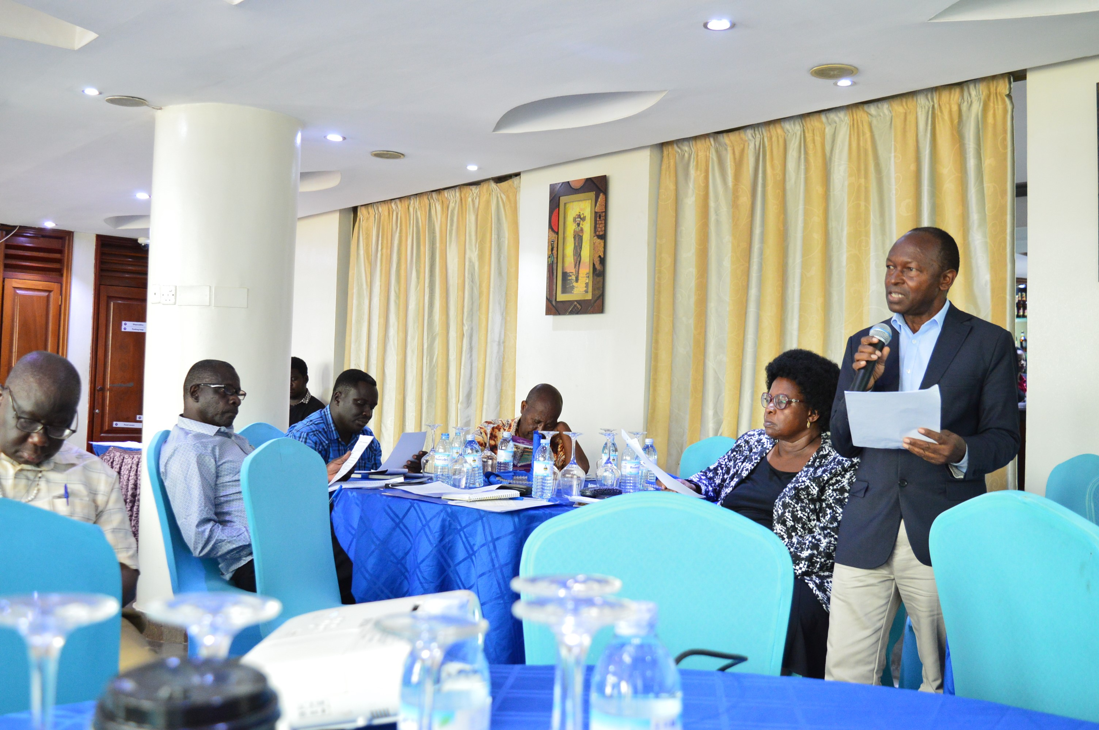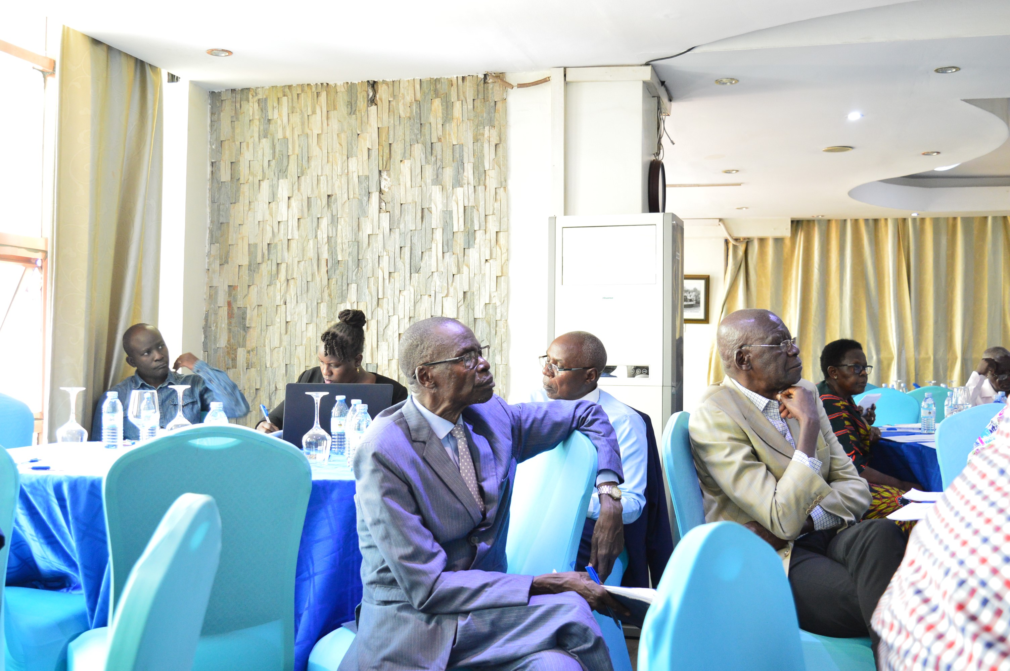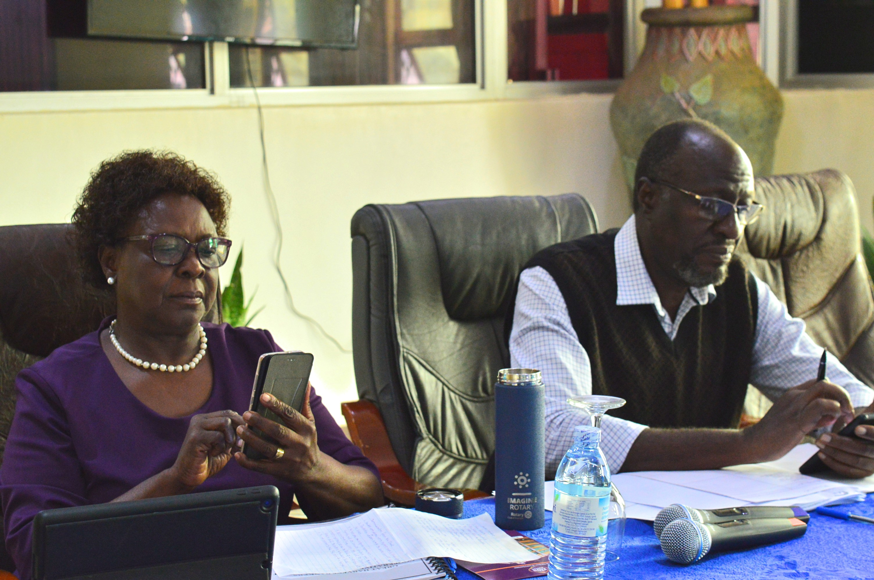

*For welfare and*

*Development*

**P.O. Box.31160, Kampala Email:greatharvestbankerssacco2024@.co**

**EQUATORIAL MALL ROOM 249**

**BANKERS SACCO (GHBS)**

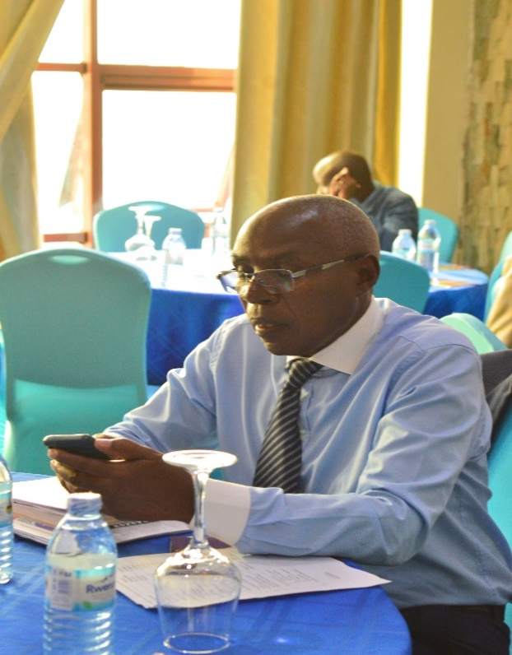

**FORMATION**: Establishment Year: 2016

**LEGAL STATUS**: It was registered on 26th October, 2021

**STRATEGY;**

**VISION**: A countrywide prosperous member-focused Savings,

Credit and investment institution by 2028

**MISSION:** To grow savings and improve members’ welfare through providing affordable products

and services while ensuring institutional profitability and sustainability.

**CORE VALUES:**

1. Integrity
2. Honesty
3. Transparency
4. Equity and Fairness
5. Excellent Customer Care

**GOVERNANCE STRUCTURE:**

1. **AGM** – 274 Membership

It meets once every year.

1. **BOARD** – 7 Member Board namely;
2. Grace Kasisira Lubuulwa – Chairperson
3. Fred Ruhakana – Vice Chairperson
4. Kezekia Kizito – Treasurer
5. Jackson Semakula – Secretary
6. Ivan Balondemu – Member
7. DTR Ogwal – Member
8. Margaret Kiggundu – Member

**C) SUPERVISORY COMMITTEE;**

1. Edward Katimbo Mugwanya – Chairperson
2. Henry Tamale – Secretary
3. Harriet Kiwanuka – Member

**D) VETTING COMMITTEE;**

1. Daniel Kaggwa – Chairperson

2. Pauline Sentongo – Member

3. Catherine Okello – Member

**E) MANAGEMENT;**

1. David Tom Ogwal – Chief Executive Officer

2. James Apali Olwol – Accounts Assistant

3. Joy Mbabazi – Credit Assistant

**F) OPERATIONS:**

**Objective;** To provide affordable financial products and services that meet the needs of members.

**PRODUCTS AND SERVICES OFFERED:**

1. **SAVINGS PRODUCTS;**
2. Mandatory Savings
3. Voluntary Savings
4. Compulsory Savings
5. Target Savings
6. Minors’/Child Savings
7. Fixed Deposits savings
8. **LOAN PRODUCTS:**
9. Quick /Online Loans
10. Emergency Loans
11. Business Loans
12. Agro – Business Loans
13. Home Improvement
14. Education/ School Fees Loans
15. Asset Acquisition Loans
16. **INSURANCE PRODUCTS:**
17. Group Life Last Expense
18. Group Life Medical Insurance
19. Group Life Credit Protection (Loans)
20. **SERVICES:**
21. Consultancy
22. Lobbying and Advocacy
23. Customer Care
24. **BENEFITS:**
25. Savings Withdrawal at any times.
26. Interest on Savings @ 5% (subject to review at the end of each year)
27. Dividends on Share Capital.
28. Loans ( 3 times a member’s savings)

**CURRENT STATUS AS AT 30TH NOVEMBER, 2024:**

1. **MEMBERSHIP NO. 273**
2. **COMPOSITION OF MEMBERSHIP;**
3. Retired BOU staff
4. Serving BOU staff
5. Close relatives of 1 and 2 above
6. **MEMBERS’ SHARE CAPITAL** – Shs.165,380,000
7. **MEMBERS’ SAVINGS** – Shs.360,047,066
8. **GROSS LOAN PORTFOLIO** – Shs.213,804,651
9. **INVESTMENTS;**
10. Short Term – Shs.266,380,937
11. Long Tem – Shs.1,000,000

**CHALLENGES:**

1. Growth in Membership (slow)
2. Inadequate Funding.
3. Growth in Products and Services (slow)

* Savings
* Shares
* Loans
* Medical Insurance.

1. Increase in dormant/ inactive savings accounts.

* Marketing

**MEMBERSHIP REQUIREMENTS:**

1. Mandatory Share Capital and Savings of Shs.1 million each member.
2. Membership Subscription of Shs.50,000
3. Annual Subscription of Shs.50,000
4. Next of Kin
5. National Identity Card.
6. Welfare of Shs.5,000